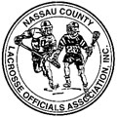
NASSAU COUNTY
BOYS LACROSSE OFFICIALS

________________________ VS ________________________
____________ /__________ /____________

Referee: ____________________________________________
Umpire: ____________________________________________
Field Judge: _________________________________________

NASSAU COUNTY
BOYS LACROSSE OFFICIALS

________________________ VS ________________________
____________ /__________ /____________

Referee: ____________________________________________
Umpire: ____________________________________________
Field Judge: _________________________________________

